Password Manager - Product Evaluation
17/08/2021
Lukasz Baldyga
Computer Forensics and Security
c3538194


Abstract

Table of Contents
Abstract 2
Introduction 5
Review of Literature 6
The mainstream encryption approach 6
AES 6
PBKDF2 6
Alternative encryption approach 6
Ciphers 7
Serpent 7
Blowfish 7
Key Derivation Functions 7
Argon2 7
Scrypt 7
Recovery 8
Bitcoin BIP39 8
Shamir’s Secret Sharing Scheme 8
Review of technologies 9
Languages 9
Python 3 + Tkinter 9
JavaScript Browser Implementation 9
JavaScript Electron Implementation 9
TypeScript 9
Electron 10
Java + Swing 10
Implementation of encryption related algorithms 10
Scrypt 10
Serpent 10
Asymmetric encryption 10
GUI design 11
Plain CSS 11
Bootstrap 11
Popper 11
BIP39 11
GIT 11
Local GIT 11
GitLab 11
GitHub 11
Methodology and Design 12
Product Development 12
Version Control 12
Object Orientated Development 12
AGILE Development 12
Waterfall Development 12
Implementation and Testing 13
Pane Classes 13
Container Object 13
Slot Object 13
Identities Object 13
Accounts Object 13
User Testing 13
Object Testing 13
Product Evaluation 14
Creating a cryptographic container 14
Recovery without password 14
Distribute recovery using Shamir’s Secret Sharing Scheme 14
Multiple passwords open container 14
Password manager features 14
Add/Remove/Update passwords 14
Exporting passwords 14
Change encryption specific settings 14
Secure password generation 14
Hosting the password manager 14
Project Evaluation 16
Time difficulties 16
Aims met 16
Summery and Conclusions 17
Bibliography 18
Appendices 20

Introduction

Review of Literature
There exist many password managers that offer similar protection as the password manager created in this project. They all fundamentally rely on symmetric or asymmetric encryption. Offline password managers, like KeePassXC, primarily rely on AES (Nechvatal et al., 1999) as the symmetric encryption cipher. The most popular password managers use AES with PBKDF2 (B. Kaliski and RSA Laboratories, 2000) (Dan Callahan and Mozilla, 2014) (LastPass, 2019).

The mainstream encryption approach

AES
The most well known and widely used, AES (also known as Advanced Encryption Standard and previously as Rijndael) (Nechvatal et al., 1999) is the mainstream approach to symmetric encryption used by password managers. This is because because AES is the most well tested and a tried algorithm at the time. Not many password managers exist that use something else other than AES. The NSA uses AES (Philip Bulman, 2000) to encrypt their most sensitive data, so it would also make sense that a lot of encryption applications would use it as their primary encryption.
Unfortunately, AES is starting to show its age. AES can take keys up to 32 bytes. Usually only 16 byte keys are secure enough for AES, however, due to the fact that quantum computers can half the brute force time in block ciphers (Lane Wagner, 2021) by using Grover’s algorithm (Grover, 1996), only using 32 byte keys is acceptable.

PBKDF2
The PBUDF2 (B. Kaliski and RSA Laboratories, 2000) key derivation function is a widely used function used to encrypt disk data (cryptsetup, 2020), as well as password managers (Dan Callahan and Mozilla, 2014) (Bitwarden, 2021). It is the algorithm recommended by NIST (Meltem Sönmez Turan et al., 2010).
The function’s cost can be updated and dynamically scaled depending on the usage. This means that as technology advances, the cost can be adjusted to be very expensive for the adversary, while keeping the user secure.
This fundamental flaw with this function is that it can be implemented as an ASIC and also accelerated by GPUs (Ondrej Mosnáˇcek, 2015). This is because of the low memory requirement by the algorithm.

Alternative encryption approach
Alternative approaches exist to encryption. Serpent (Ross Anderson, Eli Biham, and Lars Knudsen, 1998) and Blowfish (B. Schneier, 1994) encryption algorithms are examples of an alternative ciphers. There also exist new and better Key Derivation Functions, such as Scrypt (Colin Percival, 2009; Percival and Josefsson, 2016) and Argon2 (A. Biryukov et al., 2021, p. 2) (Password-Hashing.net, 2019).

Ciphers

Serpent
Serpent (Ross Anderson, Eli Biham, and Lars Knudsen, 1998) is a block cipher. It was a candidate for the Advanced Encryption Standard, and was ranked second to Rijndael. It was deemed to have a larger security margin than Rijndael (Nechvatal et al., 1999).
Like any block cipher, Serpent can take keys up to 32 bytes and suffers from the same quantum attack as AES (Philip Bulman, 2000).
The most likely reasons the Serpent algorithm was not chosen in the competition is because it is significantly slower across all platforms (Nechvatal et al., 1999) and the fact that it suffers from an attack when implemented in a smart cards (Chari et al., 1999).

Blowfish
The Blowfish algorithm (B. Schneier, 1994) is a block cipher. It can take keys up to 48 bytes in size. Like AES, Blowfish does not show evidence of being fully cracked and also produces an output that is indistinguishable from random. Blowfish has been tried and tested given its age.
The fact that Blowfish can take 56 byte keys means that it might be more secure than AES when Grover’s algorithm (Grover, 1996) is applied.

Key Derivation Functions

Argon2
The winner of the Password Hashing competition in 2019 was the Argon2 algorithm (Password-Hashing.net, 2019). There exists a draft for the Argon2 function on the Internet Engineering Task Force (IETF)’s website (A. Biryukov et al., 2021).
It allows for memory cost and time cost control independently, unlike Scrypt. This allows for greater control and also better ASIC and GPU resistance, which is the biggest threat to these algorithms.
The only problem that arises is that this is a very recent algorithm, much younger than Scrypt. This means that there hasn’t been much time for experts to give thorough scrutiny for this algorithm. There may be cryptanalysis that exists in the future for this specific algorithm. Regardless, this is also an algorithm worthy of consideration.

Scrypt
Scrypt (Percival and Josefsson, 2016) is a recent algorithm. It is a “memory hard” (Colin Percival, 2009) algorithm, meaning that it requires a lot of memory to compute in order to try and be hardware resistant. The algorithm has been designed with ASIC computation threats in mind, whereas PBKDF2 is not. In the case of this algorithm, it is possible to adjust its memory and time costs simultaneously; as computational cost rises, memory costs also rise.
However, since Scrypt is a recent algorithm it is so not as heavily scrutinised as PBKDF2 or Bcrypt. It might not be as stable as the tried and tested PBKDF2.
Like PBKDF2, it shares the same fundamental flaw: it is not ASIC or GPU resistant (anymore). The problem with adjusting the memory and time cost simultaneously is that you cannot fine tune the algorithm.

Recovery

Bitcoin BIP39
Bitcoin has it’s own improvement protocol for backing up and storing the private key of the wallet. Since the key generation in Bitcoin is deterministic given

Shamir’s Secret Sharing Scheme

Review of technologies

Languages

Python 3 + Tkinter
Python 3 is a very versatile language that is supported on virtually every platform, from embedded systems to mobile phones. It has has a brilliant package manager, pip, which would be subtile for every need.
The most unfortunate part was that Tkinter, Python’s default GUI, generally look bad and dated. There are better GUI providers like QT however, not even QT can replace the power of JavaScript in a browser. Furthermore, porting Python code with tools like PySide will require sacrifices in terms of packages that are supported and available.
Another downside is that Python family of languages are not very subtile for very large projects, like a password manager with a front end, back end and external libraries. The loosely typed language makes it difficult to develop applications that have a large scale.

JavaScript Browser Implementation
The advantage of the JavaScript current implementation would have made the password manager compatible with everything that ran the Chrome or Firefox browser, including mobile. It also wouldn’t suffer from the same problems as Python with Tkinter in the sense that it can have a modern interface.
Unfortunately, browser libraries were simply was only capable enough of the most popular algorithms, namely PBKDF2 and AES. Implementations of Argon2 or Blowfish algorithms simply did not work in a modern browser.
Furthermore, any attack on the hosting service of the website would provide an attack surface capable of leaking and stealing user’s passwords. This very simple exploitation would simply involve poisoning the JavaScript source code.
For these reasons, a browser only implementation had to be scrapped, however, this implementation was then used in the Electron implementation.

Node Implementation
The advantage of using node is that it already contains audited packages.

TypeScript
TypeScript adds types to JavaScript, along with other features for modules and
JavaScript but better. Has type checking which is very important when using a big project. Compatible with Node.
Generally better because projects are more manageable.

Electron
Electron provides a pass through layer to nodejs. This means that anything written for Electron is not directly compatible with browser. However, to add support for devices like Android, Electron can be ported to Android-JS , which is a Node.js-like library.
Android-JS ensures that every npm package can be used with Node in an android application meaning minimal changes need to be made across versions.
Another justification is using Electron for building applications. Other security projects like Signal use Electron.
Just like the browser, however, it doesn’t have the poisoning flaw.
Better support for languages.

Java + Swing
The most widely supported language out of these.
Didn’t make the cut due to caveats in maintaining and auditing external packages and libraries, especially cross platform. Auditing is important because it to have no vulnerabilities when it comes to code.

Implementation of encryption related algorithms

Scrypt
Superseded by Argon2 in terms of memory and time cost control. Memory usage can be independently controlled from time costs.

Serpent
Libraries literally non-existent or deprecated for Nodejs. Developing Serpent into NodeJS would be hard and difficult, certainly beyond the scope of this project: to make a secure password manager. Unfortunately, due to these reasons, Serpent had to be excluded from the final project.

Asymmetric encryption
Methods of asymmetric cryptography would not be susceptible for this project’s password manager. The password manager does not need to communicate with entities that they do not know. The data is stored locally and is never sent away. The requirement is for data to be secured only locally.
Furthermore, encrypting the data asymmetrically would add unneeded overhead and would be the ultimately the weakest link in the encryption for a capable attacker (for example: a government) with a quantum computer. This is because it is relatively trivial for quantum computers to factorise numbers into their prime factors (Lavor, Manssur and Portugal, 2003).
In short, there is no sense in using asymmetric cryptography to encrypt things locally, and only brings downsides to security. It’s an unnecessary risk.

GUI design

Bootstrap
Has open source MIT licensed themes. Many useful utilities.

Popper
Popper was cut because it depends on contain many unfixed vulnerabilities found by the npm auditing tool.

BIP39
Cannot be used on anything other than Bitcoin keys. That was provided by a package called “shamir-bip39”. No real NodeJS implementation. Using Bitcoin’s BIP39 has been cut out and replaced with a developed implementation that can handle more than BIP39.

GIT
GIT is a version control software, initially created by Linus Torvalds, that tracks changes in files. It is used mainly to help collaboration between developers. It is also designed with speed and data integrity in mind (Loeliger and McCullough, 2012). It is the most popular versioning control software to date (Stack Overflow, 2018).
Further expending on GIT, the online GIT hosting service “GitHub” provides further collaboration tools.

Methodology and Design

Product Development

Version Control

Object Orientated Development

AGILE Development

Waterfall Development
This approach to development was

Implementation and Testing

Implementation Phases

Prototyping
The first implementation phase was to build a working prototype, this was done by the first version of the password manager on the 27th of June, as this was the deadline underlined by an email sent out regarding the submission date. On this day there was only the first and most crude version of the password manager.

Pane Classes
Every pane has a corresponding class. These classes coordinate user actions and page responses. This also separates the code.

Container Object
The container slot is the object

Slot Object

Identities Object

Accounts Object

User Testing

Object Testing

Product Evaluation

Code Testing
All tests pass.

Creating a cryptographic container
Creating a cryptographic container implied that it could also work with only one password and that is true.

Recovery without password
Recovery without a password is possible if a user generate a BIP. This BIP can be used to recover and unlock the container without a password.

Distribute recovery using Shamir’s Secret Sharing Scheme
The recovery using Shamir’s scheme (Adi Shamir, 1979) means that the

Multiple passwords open container
Multiple passwords open the container.

Password manager features

Add/Remove/Update passwords
Yes.

Exporting passwords
Not directly. It is possible with commands in the debug version of the program, however, it is impossible to currently export the passwords out of the password manager. This is a low priority feature that wasn’t implemented in the agile development.

Change encryption specific settings
Only before creation of the first container, but it is possible to change this in a later update of the program.

Secure password generation
The program generates

Hosting the password manager
Hosting the password manager was not required as the password manager is an offline application. Initially, when the password manager was going to be a browser only application, hosting would be necessary to hold all of the source code. Since the password manager is now an offline application with all of the files bundled with it, hosting only the source code and build files is required. This is done by using GitHub.

Project Evaluation

AGILE Development

GitHub Issues

Time difficulties vs Scope

Aims met
Most of the aim have been met.

Summery and Conclusions

Bibliography
A. Biryukov et al. (2021) ‘The memory-hard Argon2 password hash and proof-of-work function draft-irtf-cfrg-argon2-13’, 11 March. Available at: https://datatracker.ietf.org/doc/html/draft-irtf-cfrg-argon2 (Accessed: 12 June 2021).
Adi Shamir (1979) ‘How to Share a Secret’, Massachusetts Institute of Technology, 22(11), pp. 612–613.
B. Kaliski and RSA Laboratories (2000) ‘PKCS #5: Password-Based Cryptography Specification Version 2.0’, September. Available at: https://www.ietf.org/rfc/rfc2898.txt (Accessed: 13 June 2021).
B. Schneier (1994) ‘The Blowfish Encryption Algorithm’, Dr. Dobb’s Journal, 19(4), pp. 38–40.
Bitwarden (2021) ‘Encryption’. Available at: https://bitwarden.com/help/article/what-encryption-is-used/ (Accessed: 12 June 2021).
Chari, S. et al. (1999) ‘A Cautionary Note Regarding Evaluation of AES Candidates on Smart-Cards’, in In Second Advanced Encryption Standard (AES) Candidate Conference, pp. 133–147.
Colin Percival (2009) ‘STRONGER KEY DERIVATION VIA SEQUENTIAL MEMORY-HARD FUNCTIONS’. Available at: https://www.tarsnap.com/scrypt/scrypt.pdf (Accessed: 13 June 2021).
cryptsetup (2020) ‘Cryptsetup and LUKS - open-source disk encryption’, What the ...?, 21 December. Available at: https://gitlab.com/cryptsetup/cryptsetup (Accessed: 14 January 2021).
Dan Callahan and Mozilla (2014) ‘Firefox Sync’s New Security Model’, Mozilla Services, 30 April. Available at: https://blog.mozilla.org/services/2014/04/30/firefox-syncs-new-security-model/ (Accessed: 12 June 2021).
Grover, L. K. (1996) ‘A Fast Quantum Mechanical Algorithm for Database Search’, in Proceedings of the Twenty-Eighth Annual ACM Symposium on Theory of Computing. New York, NY, USA: Association for Computing Machinery (STOC ’96), pp. 212–219. doi: 10.1145/237814.237866.
Lane Wagner (2021) ‘Is AES-256 Quantum Resistant?’, Qvault.io, 10 June. Available at: https://qvault.io/cryptography/is-aes-256-quantum-resistant/ (Accessed: 14 June 2021).
LastPass (2019) ‘LastPass Technical Whitepaper’. Available at: https://assets.cdngetgo.com/1d/ee/d051d8f743b08f83ee8f3449c15d/lastpass-technical-whitepaper.pdf (Accessed: 11 June 2021).
Lavor, C., Manssur, L. R. U. and Portugal, R. (2003) ‘Shor’s Algorithm for Factoring Large Integers’, arXiv e-prints, p. quant-ph/0303175.
Loeliger, J. and McCullough, M. (2012) Version Control with Git: Powerful Tools and Techniques for Collaborative Software Development. O’Reilly Media. Available at: https://books.google.co.uk/books?id=aM7-Oxo3qdQC.
Meltem Sönmez Turan et al. (2010) ‘Recommendation for Password-Based Key Derivation Part 1: Storage Applications’. NIST. Available at: https://nvlpubs.nist.gov/nistpubs/Legacy/SP/nistspecialpublication800-132.pdf (Accessed: 12 June 2021).
Nechvatal, J. et al. (1999) ‘Status Report on the First Round of the Development of the Advanced Encryption Standard’, Journal of Research of the National Institute of Standards and Technology. 1999/10/01 edn, 104(5), pp. 435–459. doi: 10.6028/jres.104.027.
Ondrej Mosnáˇcek (2015) Key derivation functions and their GPU implementation. Masaryk University, Faculty of Informatics. Available at: https://is.muni.cz/th/409879/fi_b/?lang=en.
Password-Hashing.net (2019) ‘Password Hashing Competition’, Password Hashing Competition and our recommendation for hashing passwords: Argon2, 25 April. Available at: https://www.password-hashing.net/ (Accessed: 11 June 2021).
Percival, C. and Josefsson, S. (2016) The scrypt Password-Based Key Derivation Function. RFC Editor (Request for Comments, 7914). doi: 10.17487/RFC7914.
Philip Bulman (2000) ‘Commerce Department Announces Winner of Global Information Security Competition’, 2 October. Available at: https://www.nist.gov/news-events/news/2000/10/commerce-department-announces-winner-global-information-security (Accessed: 14 June 2021).
Ross Anderson, Eli Biham, and Lars Knudsen (1998) ‘Serpent: A Proposal for the Advanced Encryption Standard’. Available at: https://www.cl.cam.ac.uk/~rja14/Papers/serpent.pdf (Accessed: 14 June 2021).
Stack Overflow (2018) ‘Stack Overflow Devloper Survey 2018’, Developer Survey Results 2018, 19 March. Available at: https://web.archive.org/web/20190530142357/https://insights.stackoverflow.com/survey/2018/#work-_-version-control (Accessed: 17 August 2021).

Appendices
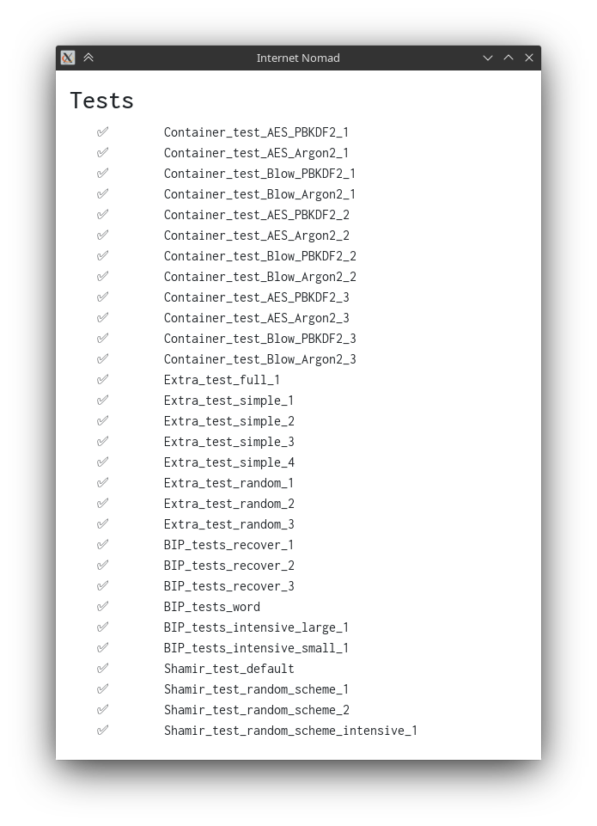Figure 1: Testing of the password manager’s components

